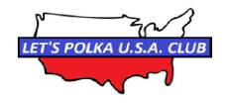
LETS POLKA U.S.A CLUB MEMBERSHIP APPLICATION
Name : Enter Name
Address : Enter Address
City, State, Zip : Enter City, State, Zip
Phone Number : Enter Phone Number
Birthday : Enter Birthday (month/day)
Membership Fee $10 / Calendar Year

Thank you for keeping Polka music alive!!!
For Questions Contact:
Norb Ciesla (708) 532-8919 or Chet Kowalkowski (815) 838-4764
Please complete the form and make check payable to "Let's Polka U.S.A. Club)
c/o: Mary H. Leja
Let's Polka U.S.A. Club
2310 Messines Ridge Court
Joliet, IL 60435

